**Test Views**

* **Test Plan Tree /for tester**

**Easy to see all the details and steps coverage**

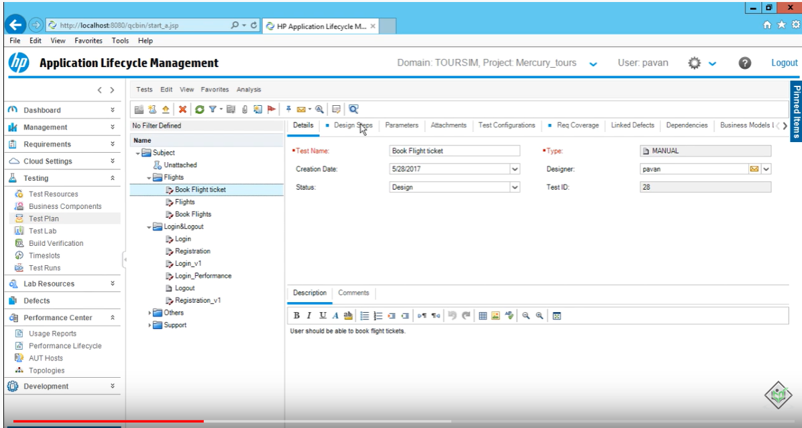

* **Test Grid /for test lead or manager**

**Easy to filter out test cases, find out the performance**

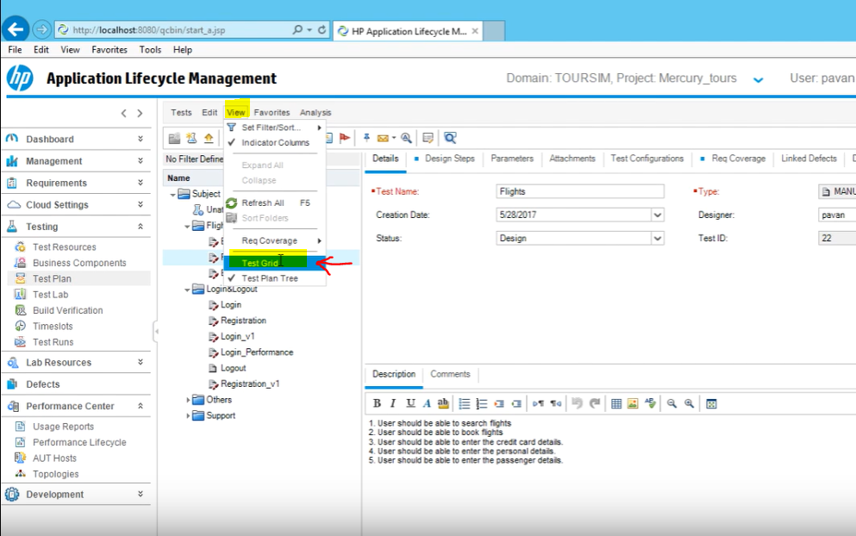

**You can use different filters to find the tests you’re looking for**

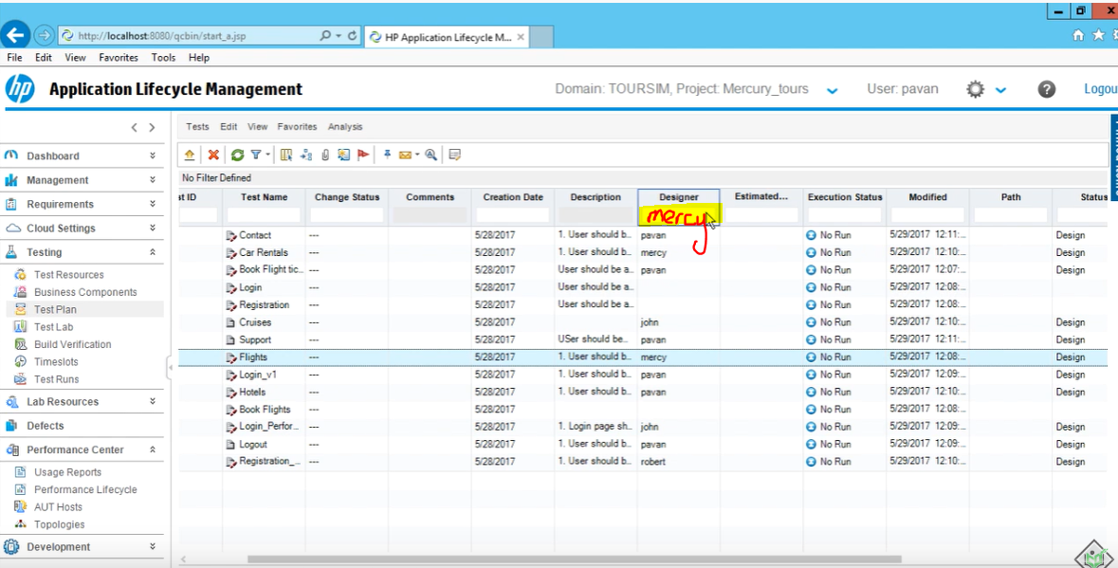

**Suppose you want to find out how many test cases mercy has created to see her performance**

**You just filter and see it**

